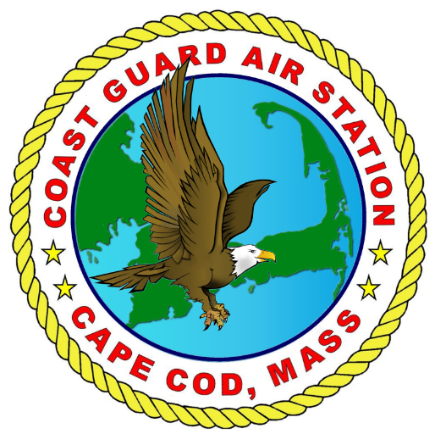

CG Air Station Cape Cod
Support Request

Thank you for your interest in the Coast Guard missions and invitation to participate in your event. Sponsors must understand that in all cases, Coast Guard participation must not interfere with Coast Guard operations and training programs, and must be at no additional cost to the U.S. Government.

Please complete sections 1-3 of this form and e-mail to D01-SMB-ASCC-PAO@uscg.mil.
If you have questions, or to follow up on a submitted request, please call (508)968-6360/6678.

- Primary Information:
Name of Event:
Requesting Agency:
Objective of the Event:
Date(s) and Time:
Duration:
Asset Request: MH-60 or HC-144?
Primary Agency POC and phone #:
Secondary POC and phone # (if avail)):

- Location:
Address:
Near-by land marks or flight hazards (if known):
Latitude/Longitude (if available):

- Amplifying Information:
Proposed Operations? Ex: Fly-by, static display, SAR demo, tour
Who is the audience? How many are expected to attend?
Has the Air Station supported this event in the past? Have other CG units supported this event in the past?
Please explain the series of events for the event and how we fit in:
Is admission being charged for the event?
Is the CG the primary attraction at the event?
Have other Government assets been requested to participate? Please explain.
Ex: other military, police, fire…etc.
Have any Media Assets by invited? Are any confirmed? Please be specific.

Comments or Additional Instructions/Requests:

