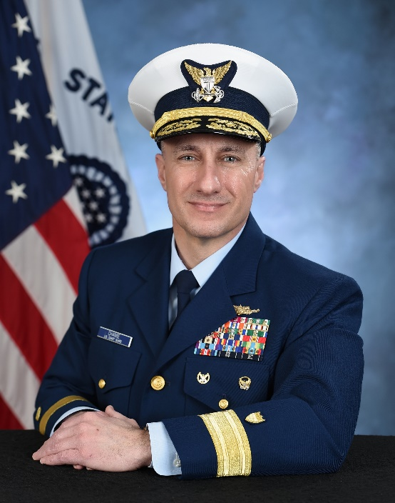
Rear Admiral Adam Chamie assumed the duties of Southeast District Commander in July, 2025. In this capacity, he is responsible for all Coast Guard operations in the southeast United States and the Caribbean Basin including Georgia, South Carolina, Florida, Puerto Rico, and the U.S. Virgin Islands. The Southeast District encompasses an area of 1.8 million square miles and shares operational borders with 34 foreign nations and territories. As Director of Operation VIGILANT SENTRY, Rear Admiral Chamie leads an interagency task force charged with deterring, preventing, and responding to illegal maritime migration.

Previously, Rear Admiral Chamie served as the Assistant Commandant for Operations Integration and Response Policy (CG-3/5R) at Coast Guard Headquarters in Washington, DC.

Rear Admiral Chamie’s command assignments include Coast Guard Sector Key West, Florida, CGC Valiant in Mayport, Florida, CGC Key Largo in San Juan, Puerto Rico, and CGC Monomoy forwarded deployed to the Arabian Gulf in support of Operation IRAQI FREEDOM. Rear Admiral Chamie served as Executive Officer of CGC Resolute in St. Petersburg, Florida and CGC Edisto in San Diego, California. His first assignment was as Communications Officer and Deck Watch Officer on board CGC Mellon in Seattle, Washington.

Rear Admiral Chamie’s staff assignments include Chief of Congressional and Governmental Affairs; Liaison to the House of Representatives; Comptroller at Training Center Cape May, New Jersey; Afloat Assignment Officer in Arlington, Virginia; and the Coast Guard’s Liaison to U. S. Naval Forces Europe, U. S. Naval Forces Africa, and U. S. Sixth Fleet in Naples, Italy.

In 2017, Rear Admiral Chamie completed a one-year National Security Fellowship at Harvard Kennedy School. He received his MBA from the University of California, Irvine Graduate School of Management, and he is a graduate of the Naval War College Command and Staff program, non-resident course. Raised in Deep River, Connecticut, Rear Admiral Chamie earned a Bachelor of Science in Management and received his commission as an Ensign from the United States Coast Guard Academy in 1996.

Rear Admiral Chamie is proud to have been designated an honorary Chief Petty Officer. His military awards include the Legion of Merit, the Meritorious Service Medal, and other personal, campaign, and unit awards. In 2002, Rear Admiral Chamie was the Coast Guard Elite Athlete of the Year in the sport of Powerlifting.

