Commander U.S. Coast Guard Sector St. Petersburg
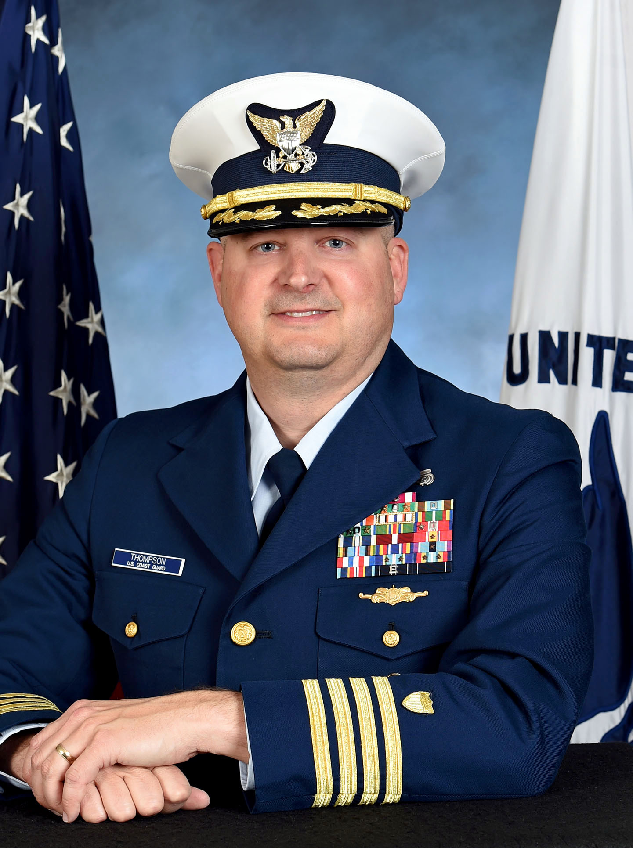

Captain Matthew A. Thompson
United States Coast Guard

Captain Thompson was most recently assigned to the Coast Guard Personnel Service Center, Officer Personnel Management Division (opm-1) as Chief of Boards, Panels, Promotions, and Separations Branch. There he directed and oversaw all active duty officer promotion boards and advanced education panels, and effected all officer promotions, retirements and separations for the nearly 8,500 member commissioned and warrant officer corps.

Captain Thompson’s most recent operational assignment was as Response Department Head at Coast Guard Sector San Francisco, California. His other operational assignments include five afloat tours as an officer and Quartermaster, while in enlisted status, and as Command Center Senior Controller at Sector San Juan, Puerto Rico. His afloat assignments include Commanding Officer of USCGC SAPELO, Executive Officer of USCGC NUNIVAK, Operations Officer of USCGC ACACIA and crewmember onboard USCGCs ATTU and OCRACOKE as an enlisted member.

He also served in staff assignments as Chief of External Affairs at the Coast Guard Eleventh District, where he oversaw and coordinated the congressional, governmental and international engagement programs, as well as on the Coast Guard Pacific Area staff as the program manager for the Maritime Law Enforcement (MLE) and Ports Waterways and Coastal Security (PWCS) missions. While at Pacific Area, he was an active member in the international North Pacific Coast Guard Forum and regularly engaged with counterparts from Canada, China, Japan, South Korea and Russia on matters of maritime governance, safety and security.

Captain Thompson holds a Bachelor of Science from Excelsior College in Management, and a Joint Professional Military Education certification through the U.S. Air Force, Air Command and Staff College. He is a permanent cutterman and holds the Advanced Boat Forces Insignia. His personal awards include two Meritorious Service Medals, four Commendation Medals, and three Achievement Medals.

He is married to Lynesh Thompson of San Juan Puerto Rico, and they have three children. Their oldest son, Maritime Enforcement Specialist Dylan Thompson, is assigned at Coast Guard Tactical Law Enforcement Team (TACLET) South in Miami, Florida. Their middle son, Ryan Thompson, studies Fire Technology at Los Medanos College in California. Isabelle Thompson, their daughter and youngest child, will attend (TBD) University as a freshman in fall 2019.

