Captain John F. Barresi, P.E.

Chief of Staff, U.S. Coast Guard, Atlantic Area

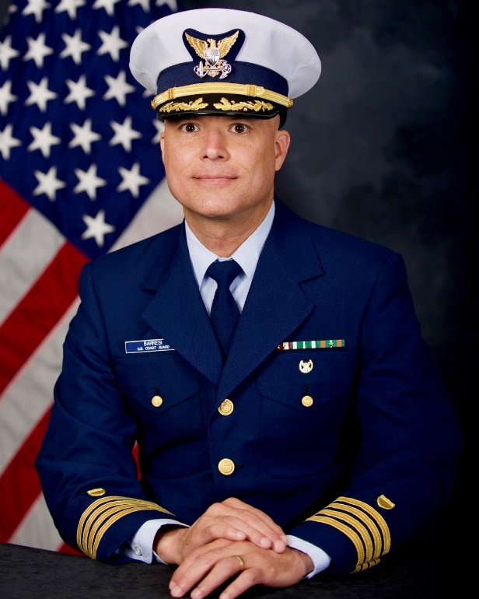Captain Barresi assumed the role as the Chief of Staff, Coast Guard Atlantic Area in June 2023. In this role, he directly supports the Area Command and Commander, Defense Force East, and manages the staff, subordinate units and major cutters responsible for all Coast Guard missions east of the Rocky Mountains to the Great Lakes, Gulf Coast, and East Coast of the United States throughout the Atlantic Ocean and adjacent parts of the Arctic Ocean to the Arabian Gulf.

He previously served as Commander, Shore Infrastructure Logistics Center (SILC), overseeing the Civil Engineering, Real Property, Environmental, and Energy Management Programs for over 6,000 buildings, 13,000 structures, and 20,000 Aids to Navigation to support logistics and mission readiness.

Prior to his assignment at SILC, he served as the Commanding Officer of the Facilities Design and Construction Center (FDCC).  At FDCC, he was responsible for the nationwide recapitalization efforts for the Coast Guard's $24 billion shore plant inventory and the planning and construction of new infrastructure, including $2 billion for hurricane reconstitution, energy, housing, and new homeports for the next generation of cutters.

Captain Barresi received his commission in 1995.  His first assignment was Project Manager and Construction Safety Officer at the Coast Guard Academy Facilities Engineering Department. Subsequent engineering assignments include Civil Engineering Unit Miami; Facilities Design and Construction Center; Director of Gulf Coast Reconstruction; Facilities Engineer at the Coast Guard Yard; and Commanding Officer of the Civil Engineering Unit in Juneau, Alaska.  Staff assignments include Executive Assistant for the Deputy Commandant for Mission Support (DCMS) at Coast Guard Headquarters.

Captain Barresi earned a Bachelor of Science in Mechanical Engineering from the University of Puerto Rico, and postgraduate degrees from Georgia Institute of Technology and the Massachusetts Institute of Technology (MIT). He is a Facilities Engineer Level II Acquisition Professional, MIT Systems Design Management Fellow, and a licensed Professional Engineer (P.E.) in the Commonwealth of Virginia and the State of Alaska.