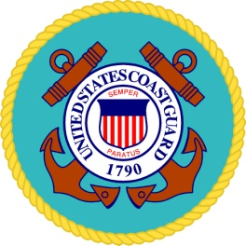
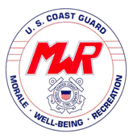Air Station Atlantic City Equipment Check-In/Check-Out

User’s First and Last Names (i.e., individual name) ___________________________________________

Type of Equipment:________________

Check out Date (DD/MM/YYYY): ________________

Return Date (DD/MM/YYYY): ________________

Initials required of custodian and user on each line below. Check-In (SAT) Check-Out (SAT)

Equipment clean _____/_____ _____/_____

Equipment serviceable _____/_____ _____/_____

Additional Comments:

____________________________________________________________________________________

____________________________________________________________________________________

By signing this document, you are certifying that you will use the equipment for its intended purpose. Additionally, you also agree to reimburse, indemnify, defend, and hold harmless the United States of America, the Department of Homeland Security, the United States Coast Guard (USCG), the USCG MWR program, its agents and employees, from all claims and causes of action that arise or may arise from your use of this USCG MWR equipment.

________________________________
(signature)

________________________________
(user name)

EMAIL or drop off with MWR Officer after filled out

