* Go to D7 [DXR - Force Readiness Reserves - Home](https://cg.portal.uscg.mil/units/d7/Planningandforcereadiness-dx/DXR-Reserves/SitePages/Home.aspx)
* Click **D7 AOR IDT Berthing request** banner

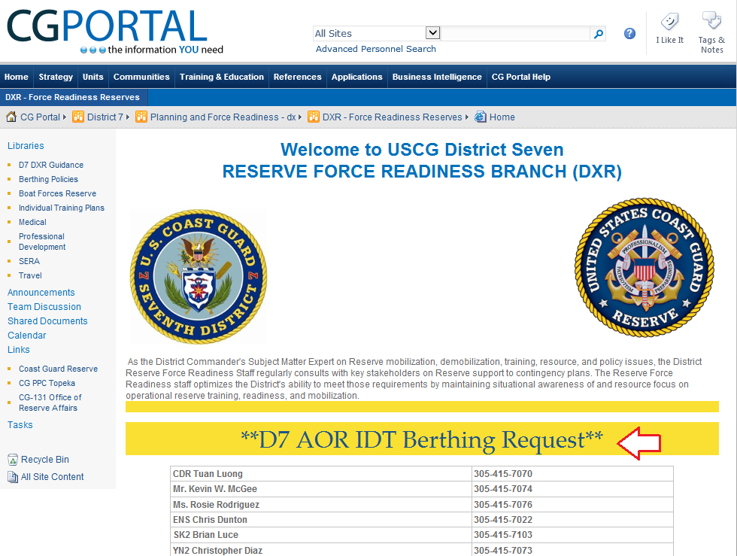

* Click Sector Jacksonville/ Station May port link

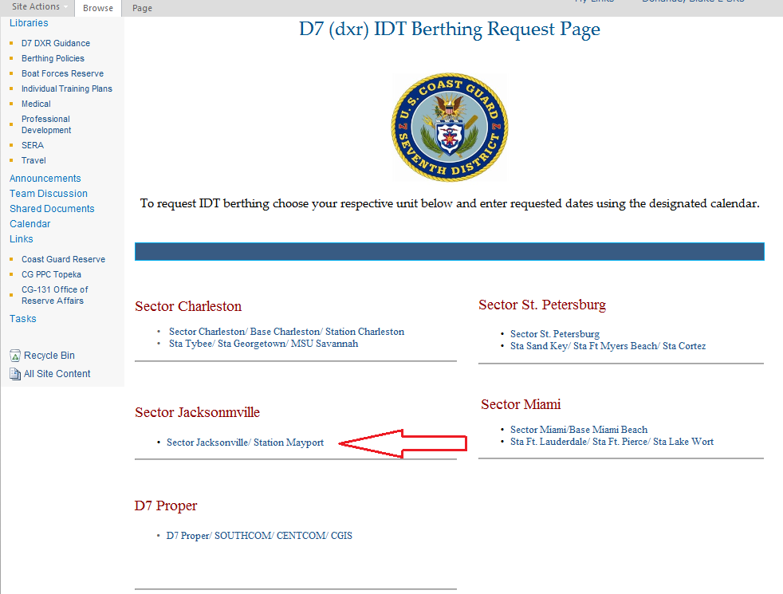

* Hover over the check in date and click the “add” link
* IF this is the 1st time using IDT calendar it will prompt you to request access. It may take five working days to receive access, IF you do not receive access contact RFRS staff for assistance.

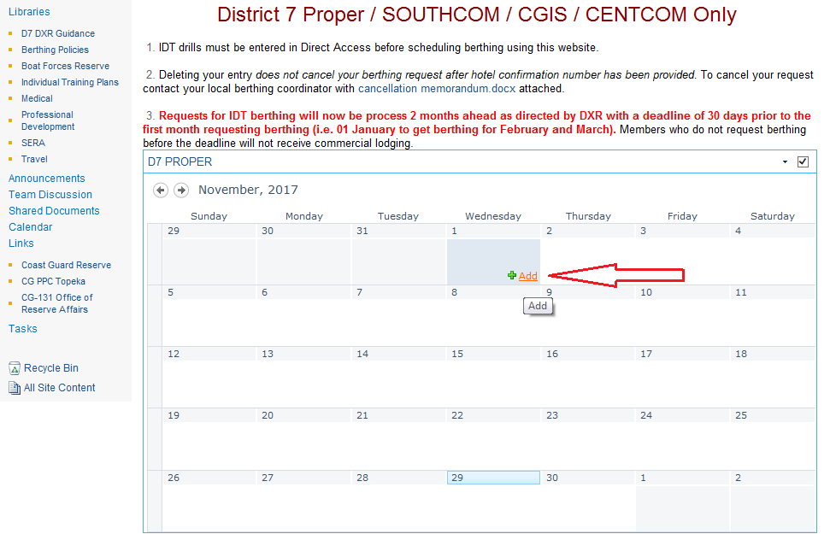

* Fill out required blocks and click all day event

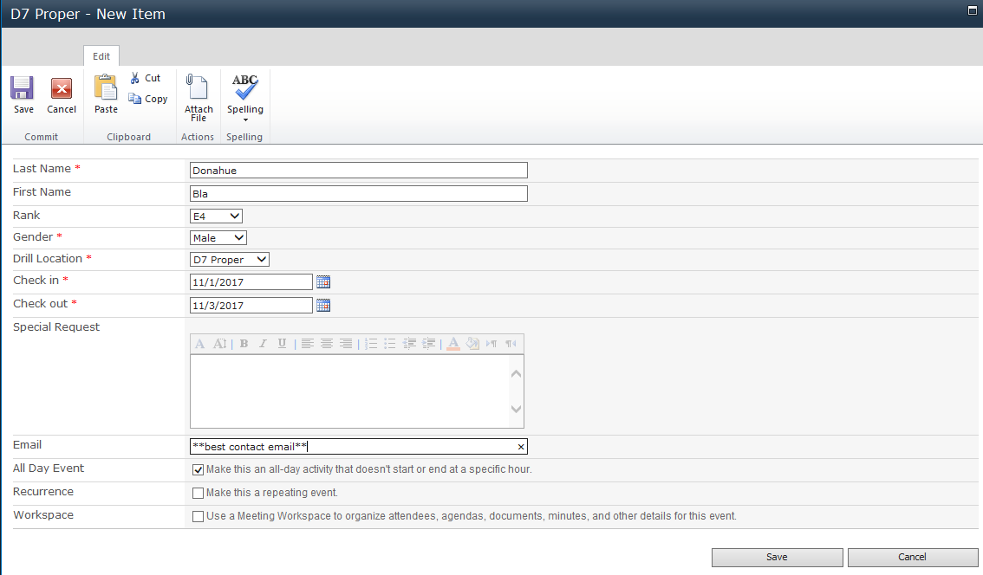

* Ensure dates and name are correct

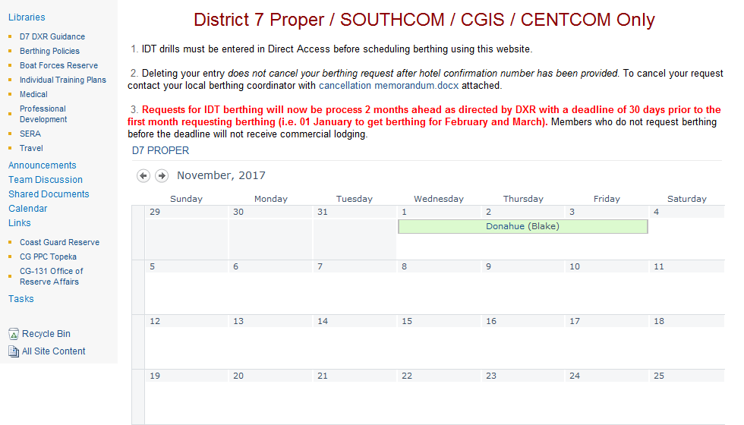

**Confirmation #s**

* Return to step 2, click Hotel confirmation Number banner.

Any changes need to be brought to Reserve Berthing Coordinator (RBC)

